**TRANSIENT STATE OF ELECTRIC CIRCUITS**

Applying Kirchhoff’s laws to a circuit with ***n*** nodes, ***ℓ*** branches, ***o* = ℓ - *n* + 1** independent loops leads to a system of ***ℓ*** equations which includes:

***n* - 1** equations expressing Kirchhoff’s current law for the ***n* - 1** nodes of the circuit:



***o* = ℓ - *n* + 1** equations expressing Kirchhoff’s voltage law for the independent loops of the circuit:



By replacing the voltages across resistors, coils and capacitors the equations expressing Kirchhoff’s voltage law becomes:



On applying the Laplace transform to the two members of KVL:



**Heaviside’s inversion theorems**

1. for the image



the original function is:



2. for the image



the original function is:

1. The circuit below is in transient state. The contact opens at the time t=0. $\text{L=0,1 H; }{\text{U}}_{\text{e}}\text{=20 V; }{\text{R}}_{\text{1}}\text{=}{\text{1 Ω; R}}_{\text{2}}\text{=4 Ω.}$

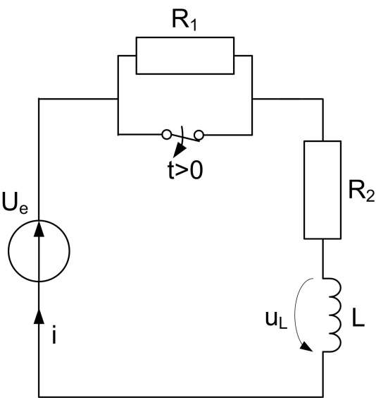

**Fig. 1a.**

For $\text{t<0}$, the circuit is as in the figure 1b.:

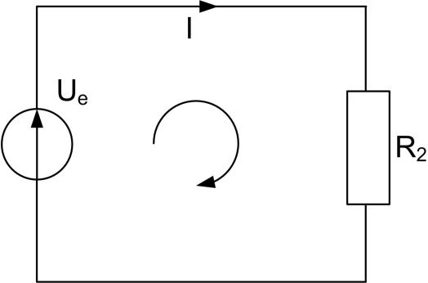

Fig. 1b

Applying the second Kirchhoff’s law:

$$\text{I}\text{∙}{\text{R}}_{\text{2}}\text{=}{\text{U}}_{\text{e}}\text{;}$$

where:

$$\text{I=}\frac{{\text{U}}_{\text{e}}}{{\text{R}}_{\text{2}}}\text{=}\frac{\text{20}}{\text{4}}\text{=5A;}$$

meaning that:

$$\text{i(0-}\text{ε}\text{)}\text{=I=5 A.}$$

For the transient state $\text{t}\text{∈}\text{(}\text{0, 4}\text{τ})$, the operational scheme is:

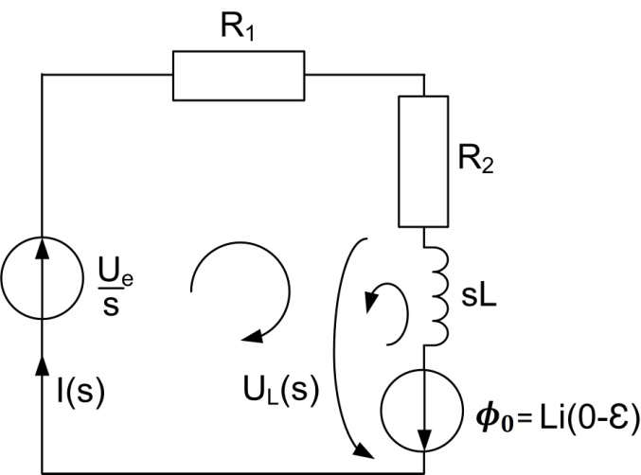

Fig. 1c

For the loop in the figure 1c it can be written:

$$\text{I}\left(\text{s}\right)\text{(}{\text{R}}_{\text{1}}\text{+}{\text{R}}_{\text{2}}\text{+}\text{sL}\text{)=}\frac{{\text{U}}_{\text{e}}}{\text{s}}\text{+5L;}$$

$$\text{I}\left(\text{s}\right)\text{=}\frac{\frac{{\text{U}}_{\text{e}}}{\text{s}}\text{+0,5s}}{\text{5+0,1s}}\text{=}\frac{{\text{U}}_{\text{e}}\text{+0,5s}}{\text{s(5+0,1s)}}\text{=}\frac{{\text{P}}_{\text{1}}\text{(s)}}{{\text{s} \text{P}}_{\text{3}}\text{(s)}}\text{;}$$

where:

$${\text{P}}_{\text{1}}\left(\text{s}\right)\text{=}{\text{U}}_{\text{e}}\text{+0,5s=20+0,5s;} \\ {\text{P}}_{\text{3}}\left(\text{s}\right)\text{=5+0,1s}$$

$${\text{P}}_{\text{3}}\left(\text{s}\right)\text{=0} \text{→}{\text{ s}}_{\text{1}}\text{=-50.}$$

The solution in instantaneous value of the current using Heaviside ‘s theorem will be:

$$\text{i}\left(\text{t}\right)\text{=}\frac{{\text{P}}_{\text{1}}\left(\text{0}\right)}{{\text{P}}_{\text{3}}\left(\text{0}\right)}\text{+}\frac{{\text{P}}_{\text{1}}\left({\text{ s}}_{\text{1}}\right)}{{\text{ s}}_{\text{1}}{\text{P}}_{\text{3}}^{\text{'}}\left({\text{ s}}_{\text{1}}\right)}{\text{e}}^{{\text{ s}}_{\text{1}}\text{t}}\text{;}$$

where:

$${\text{P}}_{\text{1}}\left(\text{0}\right)\text{=}\text{20;}$$

$${\text{P}}_{\text{3}}\left(\text{0}\right)\text{=}\text{5;}$$

$${\text{P}}_{\text{3}}\left(\text{s}\right)=\text{5+0,1s;}$$

$${\text{P}}_{\text{3}}^{\text{'}}\left({\text{ s}}_{\text{1}}\right)\text{=}\text{0,1.}$$

The solution of the differential equation is finally:

$$\text{i}\left(\text{t}\right)\text{=}\frac{\text{20}}{\text{5}}\text{+}\frac{\text{20+0,5}\text{∙}\text{(-50)}}{\text{-50}\text{∙}\text{0,1}}{\text{e}}^{\text{-50t}}=4+{\text{e}}^{\text{-50t}}\text{.}$$

The time constant will be:

$$\text{τ}\text{=}\frac{\text{1}}{\text{50}}\text{s.}$$

The variation of the current can be represented in time, figure 1d:

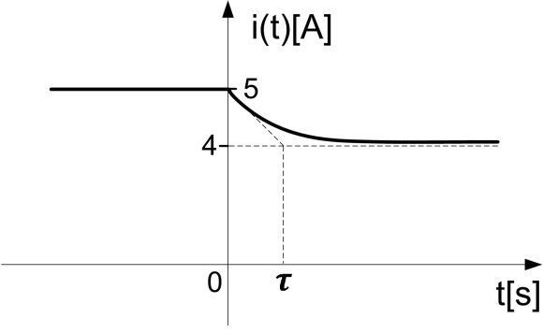

Fig. 1d

The voltage on the coil will be:

$${\text{u}}_{\text{L}}\text{(t)=L}\frac{\text{di}}{\text{dt}}\text{=0,1}\text{∙}{\text{e}}^{\text{-50t}}\text{∙}\left(\text{-50}\right)\text{=-5}{\text{e}}^{\text{-50t}}\text{.}$$

We can use also the operational scheme:

$${\text{U}}_{\text{L}}\text{(s)}\text{-}\text{I}\text{∙}\text{sL}\text{=-}\text{L}\text{∙}\text{i}\text{(0-}\text{ε}\text{)}\text{;}$$

$${\text{U}}_{\text{L}}\text{(s)=}\frac{{\text{U}}_{\text{e}}\text{+0,5s}}{\text{s(5+0,1s)}}\text{∙}\text{sL-5L=}\frac{{\text{U}}_{\text{e}}\text{+0,5s}}{\text{s(5+0,1s)}}\text{∙}\text{s}\text{∙}\text{0,1-0,5;}$$

$${\text{U}}_{\text{L}}\text{(s)=}\frac{\text{2}\text{+0,05s}}{\text{5+0,1s}}\text{-0,5=}\frac{\text{2}\text{+0,05s-2,5-0,05s}}{\text{5+0,1s}}\text{=}\frac{\text{-0,5}}{\text{5+0,1s}}\text{=}\frac{{\text{P}}_{\text{1}}\left(\text{s}\right)}{{\text{P}}_{\text{2}}\left(\text{s}\right)}\text{;}$$

where

${\text{P}}_{\text{1}}\left(\text{s}\right)=\text{-0,5}$

$${\text{P}}_{\text{2}}\left(\text{s}\right)=\text{5+0,1s}$$

The root of the denominator polynomial is: $${{\text{P}}_{\text{2}}\left(\text{s}\right)\text{=0 }\text{→} \text{s}}_{\text{1}}\text{=-50.}$$

$${\text{P}}_{\text{1}}\left({\text{s}}_{1}\right)=\text{-0,5}$$

$${\text{P}}_{\text{2}}^{\text{'}}\left(\text{s}\right)=\text{0,1}$$

The solution in instantaneous values using the first form of the Heaviside’s theorem:

$$u_{L}\left(\text{t}\right)\text{=}\frac{{\text{P}}_{\text{1}}\text{(}{\text{s}}_{\text{1}}\text{)}}{{\text{P}}_{\text{2}}^{\text{'}}\text{(}{\text{s}}_{\text{1}}\text{)}}{\text{e}}^{{\text{s}}_{\text{1}}\text{t}}\text{=}\frac{\text{-0,5}}{\text{0,1}}{\text{e}}^{\text{-50t}}\text{=-5}{\text{e}}^{\text{-50t}}.$$

The variation in time of the voltage drop on the coil is represented in figure 1e.

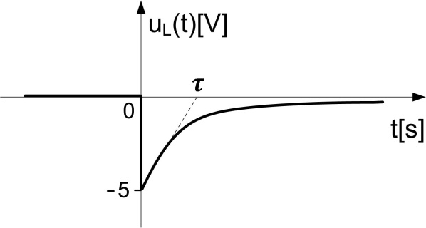

Fig. 1e

2. Knowing the elements of the circuit from figure 2 that has a contact that is opening at the time t=0, compute the currents in the branches and represent them graphically. $${\text{ L}}_{\text{1}}\text{=0,7 H; }{\text{L}}_{\text{2}}\text{=0,3 H; }{\text{U}}_{\text{e1}}\text{=190 V; }{\text{U}}_{\text{e2}}\text{=30 V; R=5 Ω.}$$

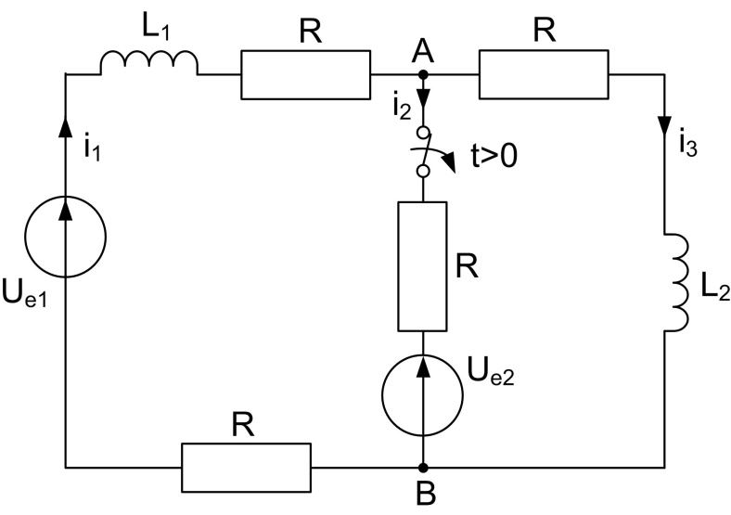

**Fig. 2a**

For $\text{t<0}$,

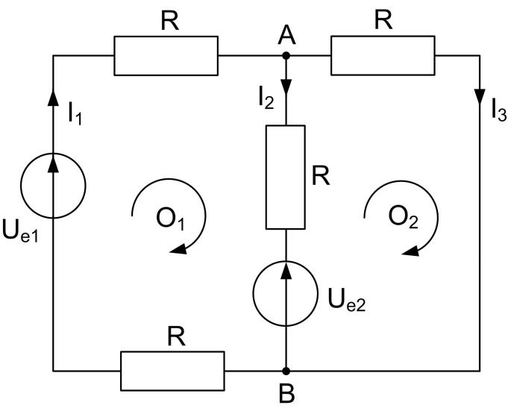

**Fig. 2b**

The equations before the transient state:

$$\left\{\begin{aligned}\begin{aligned}{{\text{O}}_{\text{1}}\text{: 2RI}}_{\text{1}}\text{+}{\text{R}\text{∙}\text{I}}_{\text{2}}\text{=}{\text{U}}_{\text{e1}}\text{-}{\text{U}}_{\text{e2}}\text{;} \\ {\text{O}}_{\text{2}}\text{:}{\text{ RI}}_{\text{3}}\text{-}{\text{R}\text{∙}\text{I}}_{\text{2}}\text{=}{\text{U}}_{\text{e2}}\text{;} \\ \text{A:}{\text{ I}}_{\text{1}}\text{=}{\text{I}}_{\text{2}}\text{+}{\text{I}}_{\text{3}}\text{;}\end{aligned}\end{aligned}\right.$$

So the currents can be computed as:

$${\text{I}}_{\text{3}}\text{=}\frac{{\text{U}}_{\text{e2}}}{\text{R}}\text{+}{\text{I}}_{\text{2}}\text{;}{ \text{I}}_{\text{1}}\text{=}\frac{{\text{U}}_{\text{e1}}\text{-}{\text{U}}_{\text{e2}}}{\text{2R}}\text{-}\frac{{\text{I}}_{\text{2}}}{\text{2}}\text{;}$$

$$\frac{{\text{U}}_{\text{e1}}\text{-}{\text{U}}_{\text{e2}}}{\text{10}}\text{-}\frac{{\text{I}}_{\text{2}}}{\text{2}}\text{=}{\text{I}}_{\text{2}}\text{+}{\text{I}}_{\text{2}}\text{+}\frac{{\text{U}}_{\text{e2}}}{\text{5}}\text{;}$$

$${\text{I}}_{\text{2}}\text{=}\frac{{\text{U}}_{\text{e1}}\text{-}{\text{3U}}_{\text{e2}}}{\text{25}}\text{=}\frac{\text{190-90}}{\text{25}}\text{=4A;}$$

$${\text{I}}_{\text{1}}\text{=}\frac{\text{160}}{\text{10}}\text{-2=14A;}$$

$${\text{I}}_{\text{3}}\text{=}\frac{\text{30}}{\text{5}}\text{+4=10 A.}$$

For the transient state $\text{t}\text{∈}\text{(0, 4}\text{τ}\text{)}$, the scheme is represented in the figure 2c:

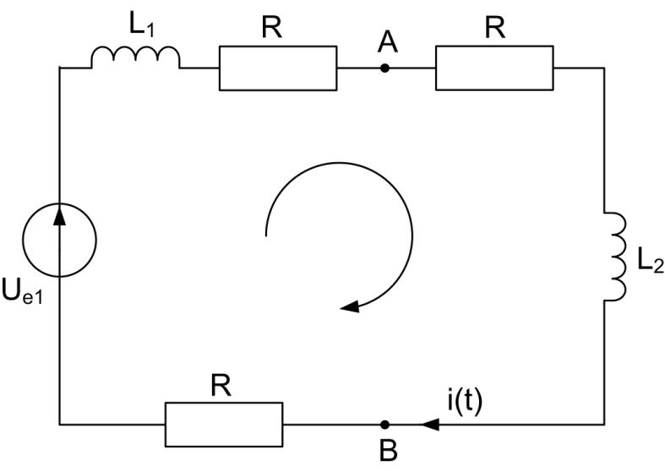

**Fig. 2c**

In series with each coil will be voltage sources having the value L1 i1(0) and L2 i3(0) respectively. Writing the second Kirchhoff law we can obtain I(s) and then applying Heaviside the original function i(t).

The solution will be

$$\text{i}\left(\text{t}\right)\text{=}\frac{\text{0,4}}{\text{3}}{\text{e}}^{\text{-15t}}\text{+}\frac{\text{38}}{\text{3}}\text{.}$$

The voltage on the coil L1 during the transient state will be:

$${\text{u}}_{{\text{L}}_{\text{1}}}\text{(t)=}{\text{L}}_{\text{1}}\frac{\text{di}}{\text{dt}}\text{=0,7}\text{∙}\left(\frac{\text{0,4}}{\text{3}}{\text{e}}^{\text{-15t}}\right)\text{∙}\left(\text{-15}\right)\text{=-1,4}{\text{e}}^{\text{-15t}}\text{.}$$

The graphical representation of the current variation in time will be as in figure 2d.

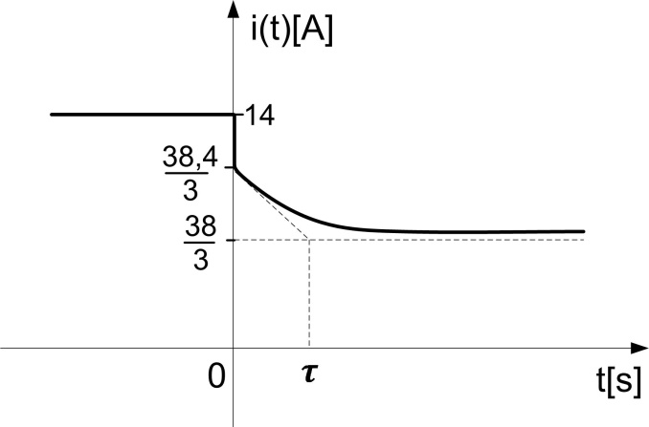

**Fig. 2d**

The graphical representation of the voltage on the coil in time will be as in figure 2e.

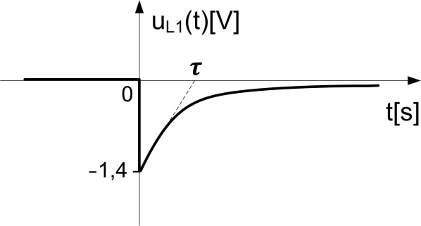

**Fig. 2e**